Marshmallow Slingshot Investigation template

Student name: ______________________________________

Group members: ______________________________________________________________________________

QUESTIONING AND PREDICTING

State the variables for this investigation.

What I will change | What I will measure | What I will keep the same
(Independent variable) | (Dependent variable) | (Controlled variables)
(4 marks)

Write the question to be investigated.
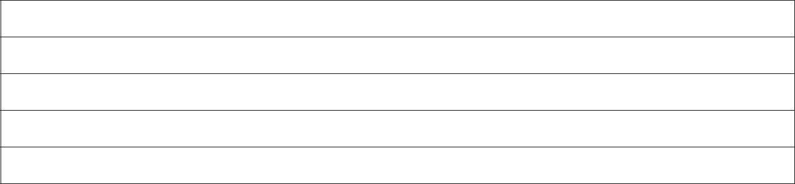

(1 mark)

Write a prediction and explain why you think this will happen.
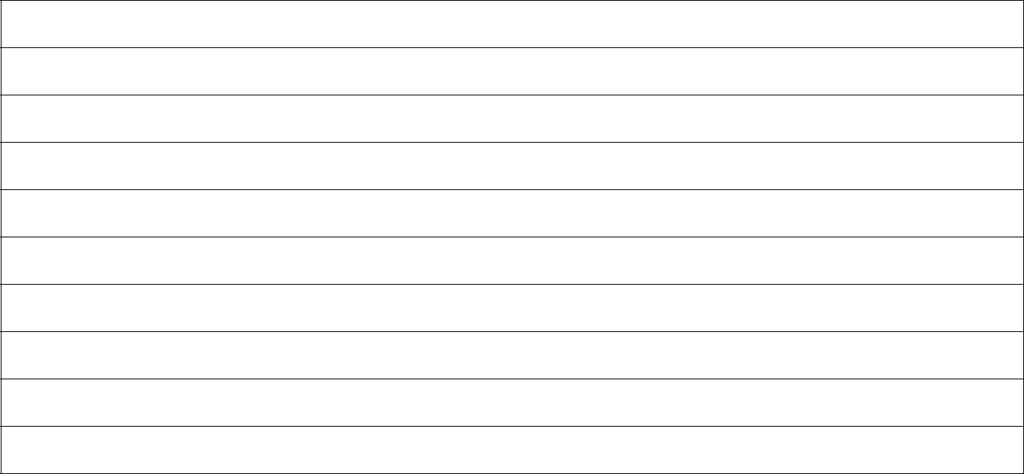

(3 marks)

Science | Year 8 | Investigation 1

PLANNING AND CONDUCTING

Copy the list of equipment required for the investigation.
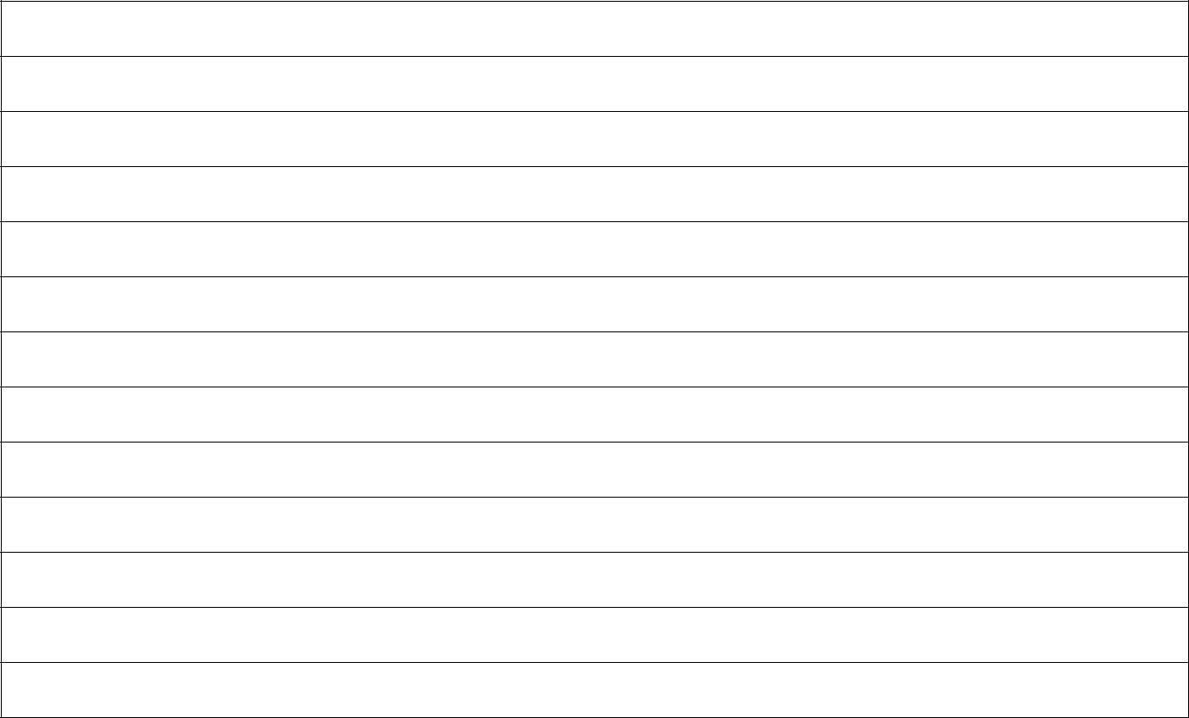

Identify the possible safety risks in this investigation and suggest how they can be managed or controlled.
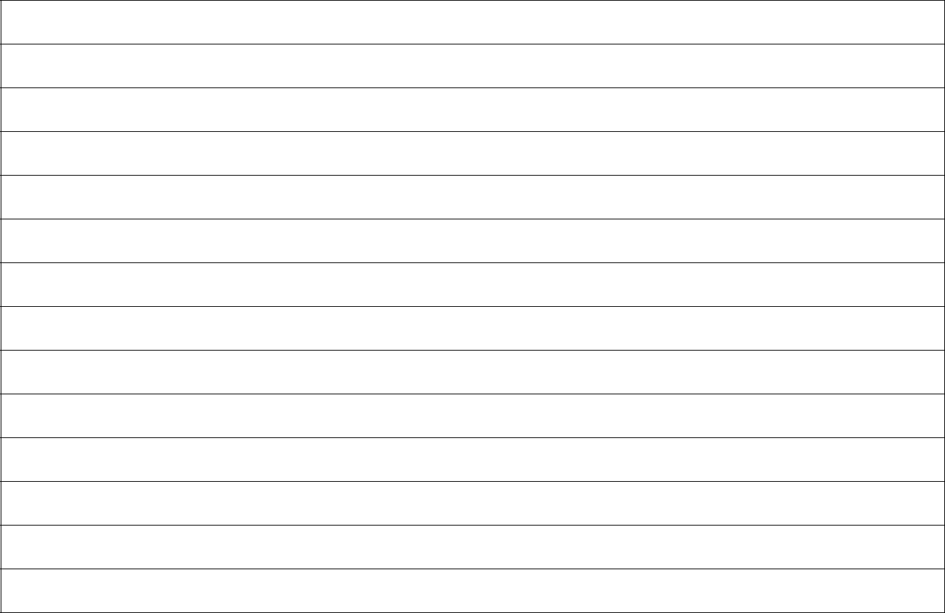

(4 marks)

Science | Year 8 | Investigation 2

Describe your observations and record your results in a table.


Table title: _________________________________________________________________________________

(3 marks)

Science | Year 8 | Investigation 3

PROCESSING DATA

Graph the results of the investigation. Label each of the axes and include appropriate units of measurement.

Graph title: _________________________________________________________________________________
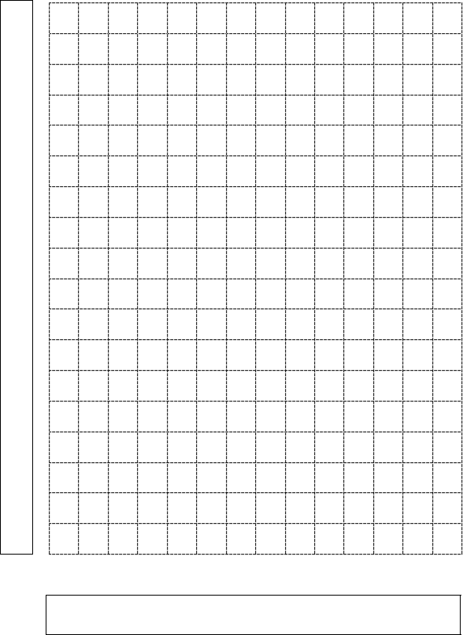

(5 marks)

Science | Year 8 | Investigation 4

ANALYSING DATA

Describe the relationships or patterns in the results.
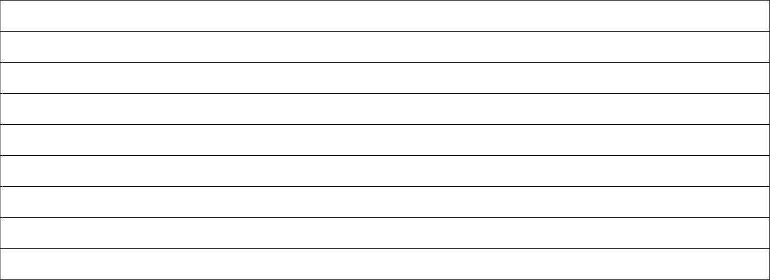

(4 marks)

Explain the relationships or patterns in the results using science ideas.

EVALUATING

Describe how the investigation could be improved.
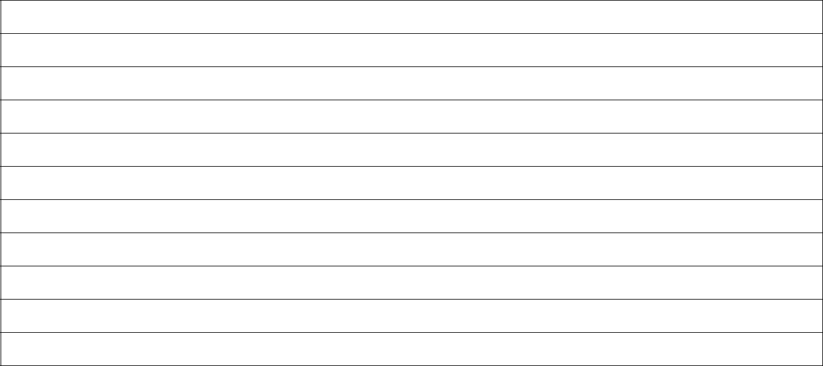

(4 marks)

Science | Year 8 | Investigation

Description | Marks
Questioning and predicting
Correctly identifies the variable to be changed (independent variable). | 1
Correctly identifies the variable to be measured (dependent variable). | 1
Correctly identifies at least two controlled variables. | 1-2
Subtotal | 4
Writes a question that can be investigated and is reasonable. | 1
Writes a prediction that describes a relationship between the dependent variable and the independent variable; and matches the question posed above. | 1-2
Provides a reasonable explanation for choosing this prediction. | 1
Subtotal | 3
Identifies safety risks associated with the investigation. | 1-2
Suggests ways to minimise the risks. | 1-2
Subtotal | 4
Draws a table that includes:  - descriptive title containing dependent and independent variables.  - information relevant to the investigation.  - appropriate column headings with units of measurement. | 1-3
Subtotal | 3
Processing data
Graphs data collected from the investigation:  - provides appropriate graph title.  - labels axes correctly.  - includes appropriate units of measurements.  - plots data correctly.  - draws the appropriate type of graph. | 1-5
Subtotal | 5
Analysing data
Describes relationships or trends in the results. | 1-2
Refers to specific data when describing relationships or trends. | 1
Compares the results to their prediction. | 1
Subtotal | 4
Evaluating
Identifies difficulties experienced when conducting the investigation.  May include reference to, but not limited to: quality of the data, correct use of equipment, choice of equipment. | 1-2
Makes suggestions to overcome the difficulties described, including ways to improve the quality of the data. | 1-2
Subtotal | 4
Total | 28

